STOCK PRICE FORECASTING WITH PUBLIC SENTIMENT USING THE ARIMA-LSTM HYBRID MODEL (CASE STUDY: BANK CENTRAL ASIA TBK)

Aditya Pratama Juliyawan¹, Dwi Lufinatul Alifah ²,
Departmen Matematika, Universitas Negeri Semarang, Semarang Indonesia
e-mail: adityajuliawan@students.unnes.ac.id , dwilufinatulalifah@students.unnes.ac.id

DOI: 10.14710/medstat.XX.X.XX-XX

Article Info:  Received:  Accepted:  Available Online:  Keywords:  Stock Price Prediction; ARIMA; LSTM; Hybrid ARIMA-LSTM; Analisis Sentimen;  BBCA  . | Abstract: Stock price prediction is a crucial component in investment decision-making, but the non-linear nature of data and the influence of external factors often limit the accuracy of traditional models. This study aims to improve the performance of BBCA's closing price prediction by combining statistical and deep learning approaches and incorporating market sentiment information as an additional feature. Four models were developed and compared: ARIMA, LSTM, a hybrid ARIMA-LSTM, and sentiment-based models LSTM-Sentiment and ARIMA-LSTM-Sentiment. Evaluation using test period data showed that the ARIMA model had a MAPE of 7.58%, while LSTM achieved 8.74%. The hybrid ARIMA-LSTM model showed significant improvement with a MAPE of 2.92%. The best performance was achieved by the LSTM-Sentiment model with a MAPE of 1.81%, which utilized daily sentiment probability scores as an additional non-linear feature. These results demonstrate that sentiment analysis is capable of capturing market dynamics not reflected in historical prices, thereby substantially improving prediction accuracy. The findings confirm that the combination of statistical models, deep learning, and sentiment information is an effective approach to modeling stock price movements in markets that are sensitive to changes in information.

- INTRODUCTION
The Indonesian stock market has experienced significant growth in recent years. In 2024, the number of individuals investing in the Indonesian capital market including stocks, bonds, and mutual funds increased to 14.84 million investors, and in 2025 this figure surpassed 15 million investors (IDX, 2025). Along with the rising level of investor participation in the capital market, the demand for forecasting methods capable of providing accurate and adaptive predictions in response to market dynamics has become increasingly critical (Zhu et al., 2025). Nevertheless, the stock market exhibits complex characteristics, including high volatility, data non-stationarity, and the influence of external factors and investor behavior that are difficult to model explicitly (Cepni et al., 2022). These conditions often lead conventional forecasting approaches to experience performance degradation when faced with rapid and unexpected changes in market conditions.
To address these challenges, this study examines stock price forecasting using both statistical and deep learning approaches, including the Autoregressive Integrated Moving Average (ARIMA) model and the Long Short-Term Memory (LSTM) network. Previous studies have demonstrated that hybrid forecasting models combining ARIMA and LSTM can effectively leverage the strengths of each approach. For instance, Kashif & Ślepaczuk (2025)developed an algorithmic investment strategy by integrating ARIMA to capture linear patterns and LSTM to model complex nonlinear relationships in stock market data. Their findings indicate that the hybrid ARIMA–LSTM model outperforms single-model approaches, particularly under volatile market conditions.
Nevertheless, reliance on historical price data and technical indicators alone is often insufficient to fully capture market dynamics. Sentiment analysis plays a critical role by incorporating the psychological factors and investor perceptions that influence stock price movements. Sentiment information derived from financial news, corporate disclosures, and social media can provide complementary signals reflecting public confidence toward a given stock (Abdildayeva et al., 2024). Accordingly, this study proposes the integration of financial news sentiment analysis into a hybrid ARIMA–LSTM framework to enhance stock price forecasting accuracy. Sentiment analysis is performed using an Indonesian pre-trained RoBERTa model to classify news headlines into positive, negative, and neutral categories, which are subsequently transformed into daily sentiment probability measures and incorporated as additional input variables in the hybrid model.
Through this approach, the study aims to contribute to the development of sentiment-enhanced hybrid forecasting models for stock price prediction in the Indonesian market and to provide practical insights for investors and financial analysts regarding the interaction between technical patterns and investor sentiment.
- LITERATURE REVIEW
  - Time Series Model
A time series is a sequence of data recorded chronologically and used to identify patterns such as trends, seasonality, and random fluctuations in order to understand data dynamics and generate future predictions. In modern analytical approaches, not only fundamental aspects such as stationarity and autocorrelation are considered, but also decomposition processes that help separate key components, making the data structure clearer. With technological advancements, deep learning methods are increasingly used because they can capture nonlinear relationships and long-term dependencies more effectively than classical techniques. Recent research also confirms that models such as LSTM, GRU, and Transformer can improve forecasting accuracy across various domains, including economics, energy, and healthcare (Kong et al., 2025).
Current developments in time-series analysis are shifting toward more adaptive methods to handle dynamic data patterns. Beyond RNNs and Transformers, decomposition-based approaches have become increasingly common because they help stabilize signals prior to modeling. Qorib et al. (2023) showed that wavelet decomposition is effective in reducing noise and improving predictive accuracy in highly volatile market data. Decomposition techniques are now widely used in time-series analysis because they can separate core signals from noise, allowing underlying patterns to be learned more clearly. This approach has been proven to enhance forecasting accuracy for data that tends to be highly fluctuating. Pandey et al. (2021) found that complete ensemble empirical mode decomposition produces smoother signals and supports forecasting models more effectively..
  - ARIMA
The ARIMA model is a time series method that predicts data based on linear patterns from previous observations. This model consists of three components: Autoregressive (AR) describes the relationship between current values ​​and previous values, Integrated (I) makes data stationary through differencing, and Moving Average (MA) represents the influence of past errors. The combination of these three makes ARIMA capable of recognizing short-term patterns and providing stable predictions on linear data (Zhang & Cao, 2025).
In research (Sherly et al., 2025) this approach can be formulated in the form of an ARIMA (p,d,q) model where p indicates the number of autoregressive lags, d is the level of differencing to make the data stationary, and q represents the lag in the moving average component. In general, the mathematical structure of ARIMA is formulated as:
(1)
$$\left(1-\sum_{i=1}^{p}{∅_{i}L^{i}}\right){\left(1-L\right)}^{d}y_{t}=c+\left(1+\sum_{i=1}^{q}{∅_{i}L^{i}}\right)∈_{t}$$

The formula explains that the forecasting value process is obtained from a combination of historical values, differences, and errors of the previous period, so that it can effectively capture linear patterns in stationary time series data.
  - LSTM
Long Short-Term Memory (LSTM) is a deep neural network architecture capable of recognizing short-term and long-term patterns in time-series data. Through memory cells that can selectively store and update information, LSTM is effectively used to model nonlinear data, seasonal patterns, and hidden trends. In research (Azeem et al., 2025), the development of an adaptive ensemble LSTM was applied to electricity load forecasting, and the model demonstrated its adaptability to concept drift changes in data patterns over time which provided increased accuracy in dynamic prediction environments.
The working structure of an LSTM is represented by a gating mechanism that regulates the flow of information at each time step. In general, the update process is formulated as follows:
(2)
(4)
(3)
$$f_{t}=σ\left(W_{f}\left[h_{t-1},x_{t}\right]+b_{f}\right), i_{t}=σ \left(W_{i}\left[h_{t-1},x_{t}\right]+b_{i}\right)$$
$${\hat{C}}_{t}=tanh\left(W_{C}\left[h_{t-1},x_{t}\right]+b_{C}\right), C_{t}=f_{t} . C_{t-1}+i_{t} . {\hat{C}}_{t}$$
$$o_{t}=σ\left(W_{C}\left[h_{t-1},x_{t}\right]+b_{C}\right), h_{t}=o_{t}.\tanh\left(C_{t}\right)$$
These equations show that LSTM retains important information through cell states and produces output representations that can capture both long-term and nonlinear patterns (Krichen & Mihoub, 2025).
  - ARIMA-LSTM Hybrid
Hybrid ARIMA–LSTM approaches combine the linear modeling capability of ARIMA with the strength of LSTM in capturing nonlinear patterns and long-term dependencies. In this scheme, ARIMA first models the linear component and produces residuals, which are then combined with other variables as inputs for the LSTM to learn more complex patterns. The integration of these two techniques helps generate predictions that are more adaptive to structural changes in the data and provides improved forecasting accuracy, particularly in highly volatile financial markets (Kashif & Ślepaczuk, 2025). Consistent with this approach, several studies have shown that combining linear and nonlinear models can operate more efficiently than single models, as each component captures distinct characteristics of the data.
Various studies have also explored hybridizing ARIMA with other models, such as SGARCH, to enhance portfolio stability and volatility prediction accuracy. More recent developments even show integrations between deep learning, reinforcement learning, and complex multivariable processing, as demonstrated by Vo & Ślepaczuk (2022), who emphasized that hybrid models can deliver better decision-making and risk management in highly dynamic market conditions. Meanwhile, Mishra et al. (2025) found that combining deep-learning-based predictive models with investor sentiment data (such as Google Trends) can improve the accuracy of return and volatility forecasts in the renewable energy sector. Overall, contemporary literature reinforces that hybrid approaches, including ARIMA–LSTM, are becoming increasingly dominant strategies because they are capable of jointly capturing linear patterns, nonlinear dynamics, and complex external factors.
  - Sentiment Analysis
Sentiment analysis is a key area in Natural Language Processing (NLP) that focuses on recognizing opinions, emotions, and attitudinal tendencies from text to more systematically understand public perception (Lak et al., 2024). This approach evolves from lexicon methods and conventional machine learning algorithms to deep learning models that are more effective at understanding linguistic context. The emergence of transformer architectures such as BERT and RoBERTa has driven significant improvements in the quality of sentiment classification, especially when dealing with complex and contextual text (Kurniadi et al., 2024). Recent research also shows that sentiment analysis is now being used not only for consumer reviews or social media, but also in decision-making in the financial, healthcare, and public policy sectors. Study (Alahmadi et al., 2025) confirmed that transformer-based models offer more consistent performance across domains and languages, making them a widely adopted modern approach in sentiment analysis.
  - RoBERTa
The RoBETa (Robustly Optimized BERT Approach) model was developed as an improvement on the BERT architecture by increasing the amount of research data, adjusting the learning strategy, and modifying the training procedure to enable the model to capture language patterns more deeply (Alhmoudi et al., 2025). With these optimizations, RoBERTa produces a more robust representation of word context and is more sensitive to variations in meaning, especially when processing text with complex structures or indirect meanings. This approach makes RoBERTa superior to previous methods in sentiment analysis tasks (Huang et al., 2025).
In sentiment analysis, RoBERTa has proven superior due to its ability to recognize relationships between words within sentence contexts and distinguish subtle emotional nuances, both in long sentences and short texts such as tweets and news headlines. Compared to traditional embedding-based models, RoBERTa is able to handle informal language, varying speech styles, and linguistic components frequently appearing in social media, such as slang, abbreviations, and irregular sentence structures (Paneru et al., 2025). Recent research confirms that RoBERTa delivers more stable and accurate performance across a wide range of text domains, making it one of the most reliable models for modern sentiment classification tasks. (Liu et al., 2019).

- MATERIAL AND METHOD
  - Data Sources
The data used in this study consists of historical stock price data for PT Bank Central Asia (BBCA) and public sentiment data obtained from online news headlines. BBCA stock price data was scraped through the Yahoo Finance platform for a period from January 2015 to October 2025, resulting in a total of 2,652 daily data points. The variables used include the opening price (Open), the highest price (High), the lowest price (Low), the closing price (Close) as prediction targets, and trading volume (Volume). Initial visualizations indicate that BBCA's stock price has experienced a long-term upward trend with several periods of aggressive volatility, particularly during volatile market conditions.
Public sentiment data was obtained through web scraping of BBCA-related news headlines from three national media portals, namely Kompas, Detik, and CNBC Indonesia, for the period 2015–2025. The headlines were then processed using the RoBERTa model to generate sentiment labels, which were then converted into daily scores. On days when no news was found, the sentiment score was classified as neutral to maintain time series continuity. All text underwent preprocessing stages, including character cleaning, normalization, and removal of irrelevant elements. The final result, a daily sentiment time series, was aligned with stock price data through date matching so that it could be used as an additional feature in LSTM and ARIMA–LSTM-based modeling.

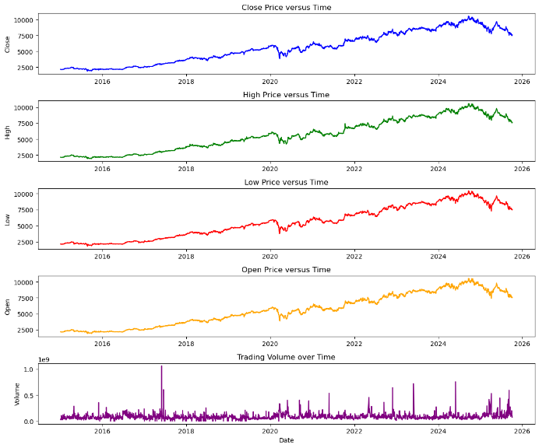
Figure 1. Data Distribution

  - Research Flow
The research workflow begins with the collection of two types of data, namely daily BBCA stock price data and financial news headlines obtained from several national media portals, as illustrated in Figure 2. The news data first undergo a preprocessing stage consisting of text cleaning and normalization. The processed headlines are then analyzed using a pre-trained IndoRoBERTa model to generate daily sentiment scores representing the probabilities of negative, neutral, and positive sentiment.
Subsequently, the daily sentiment scores are merged with the stock price data based on date alignment, resulting in a multivariate time series dataset. The stock price data are then tested for stationarity using the Augmented Dickey-Fuller (ADF) test, and differencing is applied when necessary to satisfy the stationarity assumption.
The next stage involves the development of prediction models. The ARIMA model is first employed to capture the linear components of the closing price (Close). The difference between the actual values and the ARIMA predictions is calculated as residuals, which represent non-linear patterns not captured by the ARIMA model. These residuals are subsequently incorporated as additional input variables in the LSTM model. This study evaluates three main modeling approaches: ARIMA–LSTM, LSTM–Sentiment, and ARIMA–LSTM–Sentiment, which combine historical stock price features, ARIMA residuals, and daily sentiment scores.
Finally, the performance of all evaluated models, including ARIMA as a baseline model, is assessed using Root Mean Square Error (RMSE), Mean Absolute Error (MAE), and Mean Absolute Percentage Error (MAPE). This evaluation aims to identify the most optimal model for predicting BBCA stock prices, as depicted in Figure 2.

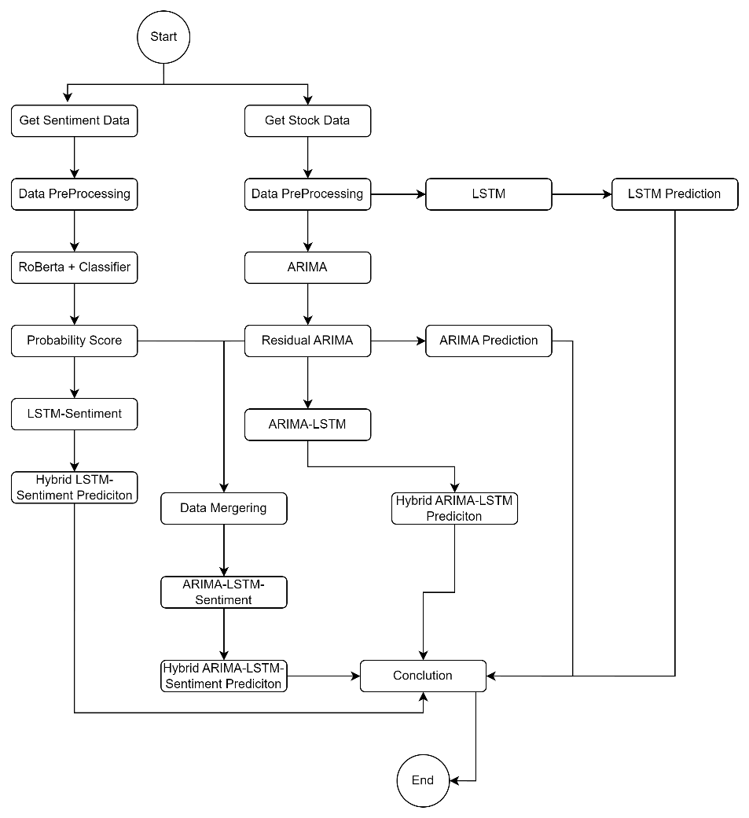

Figure 2. Research Flowchart
  - Model Development and Hybrid Architecture
To comprehensively capture both linear and nonlinear dynamics in BBCA stock price movements, this study develops and evaluates several predictive models, namely ARIMA, LSTM, LSTM–Sentiment, ARIMA–LSTM, and ARIMA–LSTM–Sentiment. These models are designed to progressively incorporate price-based patterns and market sentiment information in order to assess their individual and combined contributions to forecasting accuracy.
The ARIMA model is first applied to the closing price series to model linear temporal dependencies. Prior to modeling, the stationarity of the time series is examined using the Augmented Dickey-Fuller (ADF) test. Since the original series exhibits non-stationary behavior, first-order differencing is applied to stabilize the mean.
The optimal ARIMA parameters (p,d,q) are selected based on Autocorrelation Function (ACF) and Partial Autocorrelation Function (PACF) analyses, supported by Akaike Information Criterion (AIC) and Bayesian Information Criterion (BIC) values. Based on these criteria, the ARIMA(2,1,1) model is selected as the most suitable configuration for capturing the linear structure of the BBCA stock price series.
The fitted ARIMA model generates both predicted values and residuals. These residuals represent nonlinear patterns and irregular fluctuations that cannot be captured by linear modeling alone and are therefore extracted for further processing using deep learning techniques.
Long Short-Term Memory (LSTM) networks are employed to model nonlinear relationships and long-term dependencies in stock price movements. As a baseline deep learning approach, the LSTM model is trained using historical stock price features without incorporating ARIMA residuals or sentiment information. The LSTM architecture consists of multiple LSTM layers followed by Batch Normalization and Dropout layers to enhance training stability and prevent overfitting. A fully connected Dense layer is used to produce the final output. The model is trained using the Adam optimizer with Mean Squared Error (MSE) as the loss function. Early stopping is implemented to terminate training when validation loss fails to improve, thereby ensuring model generalization.
To incorporate market perception and investor psychology, sentiment probability scores derived from financial news headlines are integrated into the LSTM model. In this configuration, daily sentiment probabilities (positive, neutral, and negative) generated by the IndoRoBERTa model are concatenated with stock price features and used as additional input variables to the LSTM network. This LSTM–Sentiment model aims to evaluate whether sentiment information alone, without linear decomposition, can enhance forecasting performance by capturing behavioral signals that influence price movements.
The ARIMA–LSTM hybrid model is constructed to combine the strengths of linear and nonlinear modeling. In this approach, ARIMA predictions capture the linear component of the stock price series, while the extracted residuals are used as input for the LSTM network to learn nonlinear structures. The final forecast is obtained by summing the ARIMA linear prediction and the LSTM prediction of residuals. This hybrid structure allows the model to separately learn linear trends and nonlinear fluctuations, thereby improving adaptability under volatile market conditions.
The most comprehensive model proposed in this study is the ARIMA–LSTM–Sentiment model. In this configuration, both ARIMA residuals and daily sentiment probability scores are incorporated as input features in the LSTM network. By integrating historical price information, linear residuals, and sentiment signals, this model simultaneously captures technical market dynamics and psychological investor behavior. This hybrid architecture is designed to evaluate whether sentiment-enhanced residual modeling can further improve forecasting accuracy compared to price-based hybrid models.
  - Model Evaluation
Evaluation was conducted to assess the ability of each model to predict BBCA's closing stock price on the test data. The evaluation process used three main error metrics: Mean Absolute Error (MAE), Root Mean Square Error (RMSE), and Mean Absolute Percentage Error (MAPE), which represent the absolute error rate, the mean square error rate, and the percentage deviation of the model from the actual value, respectively. All models ARIMA, LSTM, LSTM–Sentiment, ARIMA–LSTM, and ARIMA–LSTM–Sentiment were trained using an 80:20 data split, where the models were evaluated solely based on their performance on the test data to prevent bias due to the data used during training.

- RESULTS AND DISCUSSION
The development of the ARIMA model begins with an examination of the stationarity of the time series, as stationarity is a fundamental assumption in ARIMA modeling. To assess this property, the Autocorrelation Function (ACF) and Partial Autocorrelation Function (PACF) plots are analyzed, providing insights into the underlying structure and trend behavior of the data.
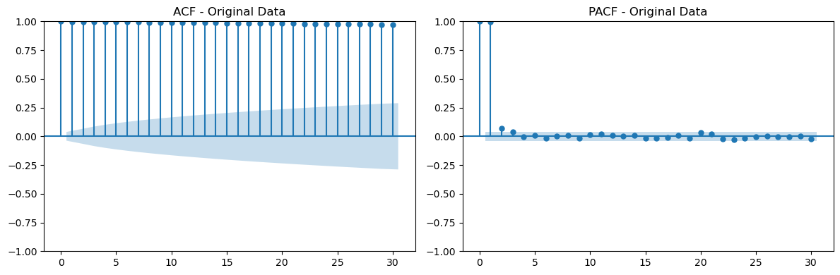
Figure 3. Plot Before Stationery ACF and PCF
From Figure 3 before differencing, the ACF plot exhibits a consistently high and nearly flat autocorrelation value close to 1 across all lags, indicating strong persistence in the series. Meanwhile, the PACF shows significant spikes at lag 0 and lag 1, followed by a sharp decline at higher lags. This pattern suggests the presence of a deterministic trend and confirms that the original time series is non-stationary, as the autocorrelations do not decay rapidly with increasing lags.

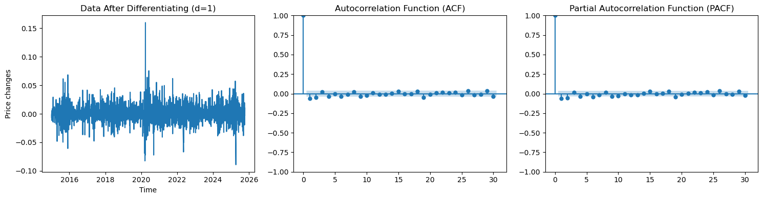
Figure 4. Stationary Plots ACF and PCF
After applying first-order differencing, the characteristics of the time series change substantially. The ACF retains a high value at lag 0, as expected, but the autocorrelations at subsequent lags decrease rapidly and remain relatively small (below 0.25). Similarly, the PACF displays a more stable and controlled pattern beyond lag 1, with no dominant spikes at higher lags. These results indicate that the differencing process has effectively removed the trend component, thereby transforming the series into a stationary form suitable for ARIMA modeling.
Based on the model selection process using auto-ARIMA, the best model was ARIMA(2,1,1) with the lowest AIC value. The model was then trained on data from 2015-2024 and tested over the period of September 2024-2025. Model performance showed an MAE of 347.17, an RMSE of 403.19, and a MAPE of 3.73%. These results indicate that ARIMA is quite good at capturing long-term linear patterns, but is still less responsive in tracking daily stock price volatility.
Comparison with the LSTM model shows that this non-linear approach is capable of providing a more adaptive response to price changes. LSTM achieved an MAE of 803.20, an RMSE of 844.42, and a MAPE of 8.74%. While its performance isn't completely superior to ARIMA, on actual forecast charts, LSTM is better able to follow the trend direction.
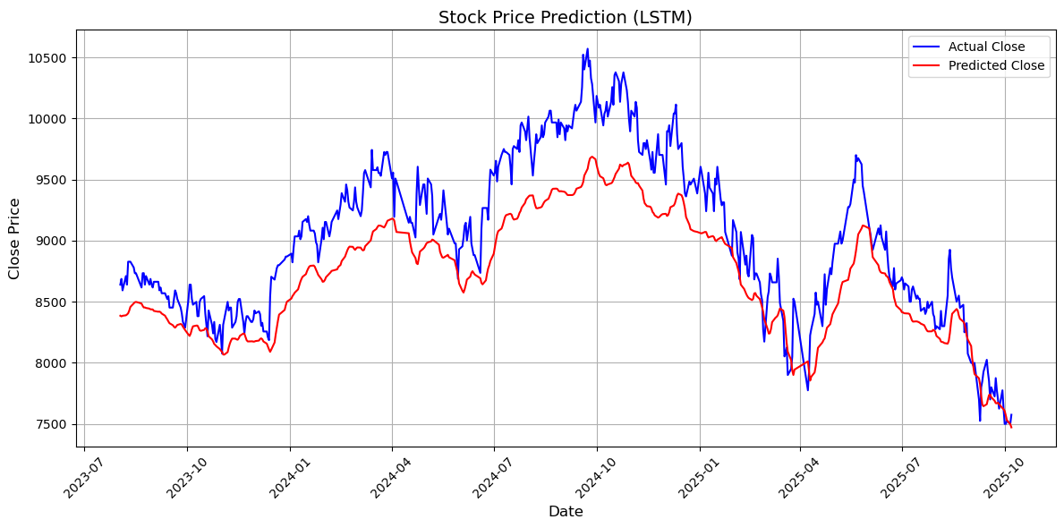
Figure 5. LSTM Prediction
Model performance improves significantly when linear and nonlinear approaches are combined in a hybrid ARIMA-LSTM model. The ARIMA residuals, representing the nonlinear components that cannot be explained by the linear model, are learned by the LSTM, enabling the model to address two key characteristics of stock data. The hybrid model achieves an MAE of 275.95, an RMSE of 362.23, and a MAPE of 2.92%, demonstrating significant improvements over the single model. The predicted-actual graph shows that the hybrid model follows the price pattern more smoothly and stably, indicating that the sharing of learning burden between ARIMA and LSTM is effective in modeling the complex dynamics of stock data.
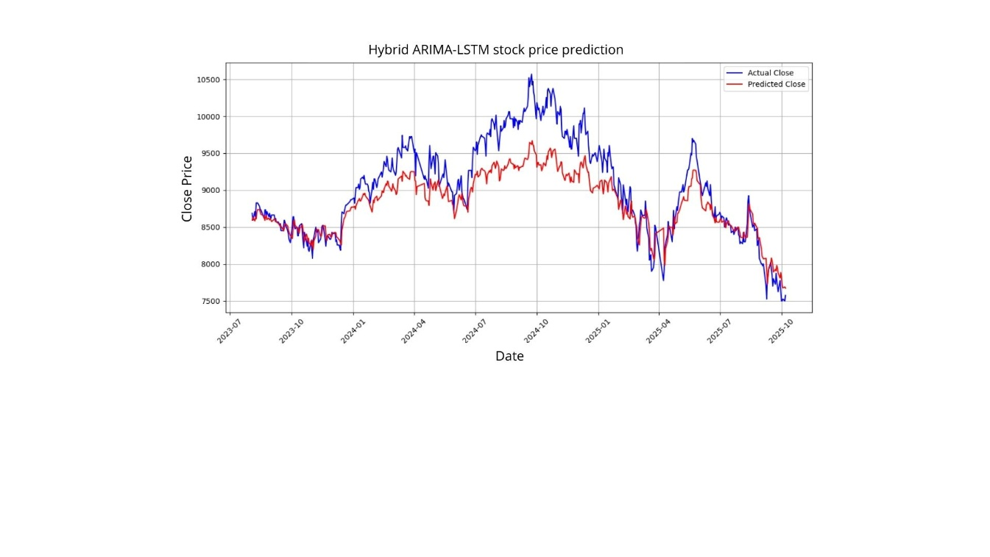
Figure 6. Hybrid ARIMA-LSTM Stock Prediction
The integration of sentiment information provided the most drastic performance improvement. The LSTMSentiment model, which combines price features and sentiment score probabilities, performed best with an MAE of 165.19, an RMSE of 207.22, and a MAPE of 1.81%. Public sentiment from news provides real-time signals about market perceptions that historical prices cannot capture. This model demonstrated a faster response to changing market conditions, resulting in more accurate tracking of BBCA price fluctuations.
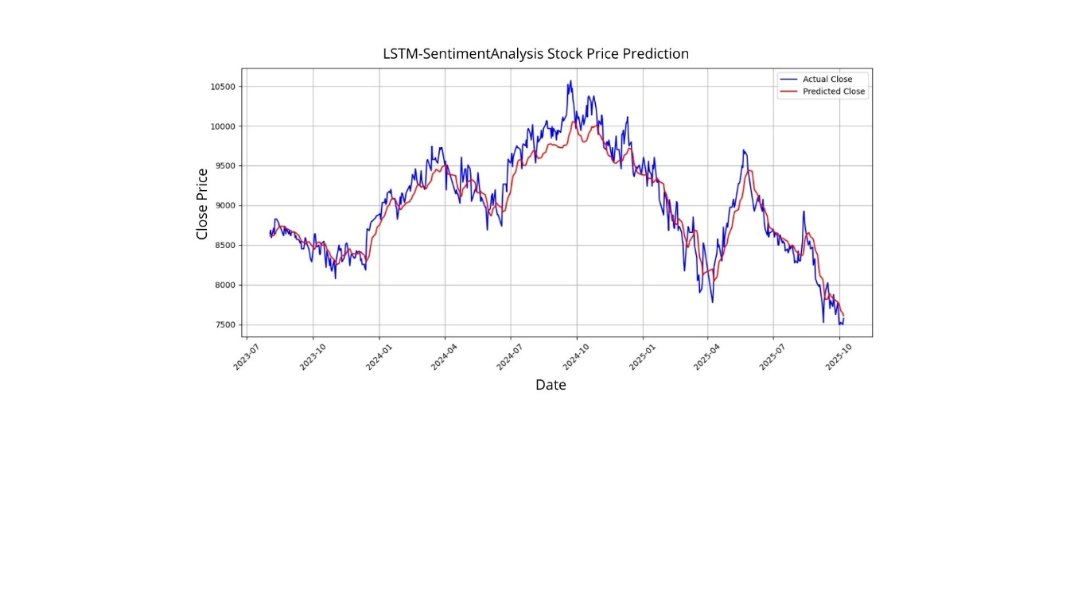
Figure 7. LSTM-Sentiment Analysis Stock Price Prediction
When sentiment was added to the hybrid framework, the ARIMA-LSTM-Sentiment model achieved an MAE of 288.21, an RMSE of 355.60, and a MAPE of 3.06%. While still outperforming both ARIMA and LSTM alone, it was slightly lower than LSTM-Sentiment. This indicates that in the BBCA data, the contribution of public sentiment is more dominant than the contribution of the ARIMA residual linear component. In other words, stock price fluctuations are more sensitive to news dynamics and investor perceptions than historical linear patterns.
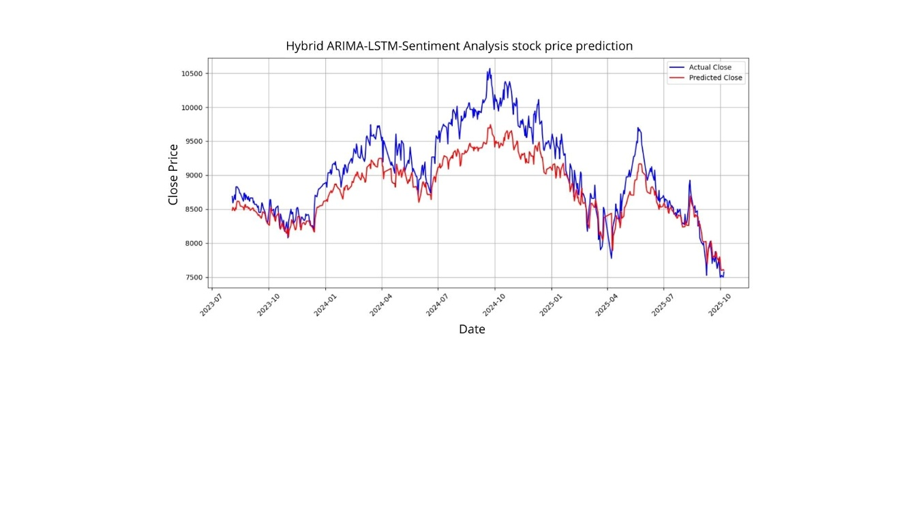
Figure 8. Hybrid ARIMA-LSTM-Sentiment Analysis Stock Price Prediction
Overall, the evaluation results show that the sentiment-based model provides the best performance. The integration of non-technical information such as sentiment has been shown to improve the model's ability to capture market dynamics. The evaluation table for all models confirms that LSTM–Sentiment provides the best accuracy, while ARIMA is only able to serve as a baseline that captures the main trend without being able to read market emotions. These findings suggest that a multivariate approach incorporating external signals is more suitable for predicting BBCA stock price movements, which are heavily influenced by daily information dynamics.
Table 1. Comparison of Model Evaluation
No | Model | MAE |  | RMSE |  | MAPE
1. | ARIMA |  | 902.89 |  | 656.24 |  | 7.58%
2. | LSTM |  | 347.17 |  | 403.19 |  | 3.73%
3. | ARIMA-LSTM |  | 275.95 |  | 362.23 |  | 2.92%
4. | LSTM-Skor Sentimen |  | 165.19 |  | 207.22 |  | 1.81%
5. | ARIMA-LSTM-Skor Sentimen |  | 288.21 |  | 355.60 |  | 3.06%
This study shows that the LSTM Sentiment model achieved a MAPE of 1.81%, significantly lower than the ARIMA model (MAPE of 7.58%) and the ARIMA–LSTM model (MAPE of 3.06%). This is consistent with the results of a study conducted by Ko & Chang (2021) entitled LSTM-based Sentiment Analysis for Stock Price Forecast, which reported that combining historical price data with news/forum sentiment can improve accuracy, namely a decrease in error (based on RMSE) of around 12.05% compared to the model without sentiment. Another study conducted by Kashif & Ślepaczuk (2025), Performance Analysis of ARIMA, LSTM, and Hybrid ARIMA LSTM in Forecasting the Composite Stock Price Index (2025), showed that the hybrid ARIMA LSTM model was able to reduce the MAPE to around 2.00 - 1.74% at closing and opening prices.
Thus, the results of this study are not only in accordance with the literature but in the case of the model with sentiment, its performance is even superior (1.81%) compared to the hybrid benchmark without sentiment indicating that the addition of sentiment can make a real contribution to prediction accuracy, especially for stocks such as BBCA which are very sensitive to the dynamics of public information.
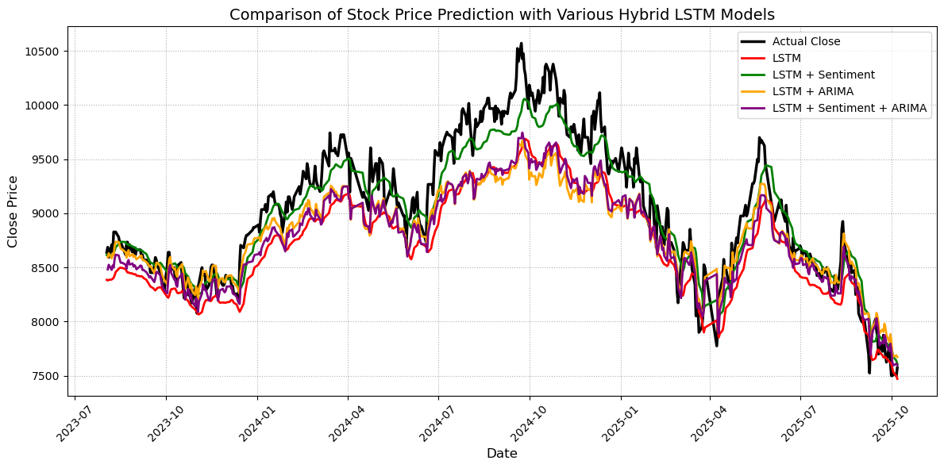
Figure 9. Model Prediction Performance Comparison
- CONCLUSION
Based on the comparison results of the five models used, the LSTM-Sentiment Score model showed the best performance with the lowest error values ​​(MAE, RMSE, and MAPE) compared to the other models. This indicates that the addition of sentiment information to the LSTM model can improve the model's ability to recognize stock price movement patterns more accurately. Conversely, the ARIMA model had the highest error rate, so it was considered the least accurate in predicting stock prices. Meanwhile, the hybrid ARIMA-LSTM model still showed good performance, but was not as accurate as the LSTM-Sentiment Score.

ACKNOWLEDGMENT
The authors can add in the acknowledgement if they would like to express their appreciation for the support of the sponsors with certain Project No, individual or organization/institution.

REFERENCES
Abdildayeva, A., Nurtugan, G., Taganova, G., & Akhmetova, A. (2024). Stock Closing Price Forecasting Using LSTM, Sentiment Analysis, Kalman Filter. Journal of Computer Science, 20(11), 1388–1396. https://doi.org/10.3844/jcssp.2024.1388.1396
Alahmadi, K., Alharbi, S., Chen, J., & Wang, X. (2025). Generalizing sentiment analysis : a review of progress , challenges , and emerging directions. Social Network Analysis and Mining. https://doi.org/10.1007/s13278-025-01461-8
Alhmoudi, O. K., Thameem, M., Elkamel, A., & AlHammadi, A. A. (2025). Low-Compute repurposing of an English transformer into a molecular encoder: A two-stage SELFIES adaptation of RoBERTa. Results in Engineering, 28, 108390. https://doi.org/10.1016/j.rineng.2025.108390
Azeem, A., Ismail, I., Sheeraz, S., Usman, K., Hussain, U., Shabbir, S., Zaman, R., & Jusoh, B. (2025). Mitigating concept drift challenges in evolving smart grids : An adaptive ensemble LSTM for enhanced load forecasting. Energy Reports, 13(December 2024), 1369–1383. https://doi.org/10.1016/j.egyr.2024.12.078
Cepni, O., Gupta, R., & Onay, Y. (2022). The role of investor sentiment in forecasting housing returns in China: A machine learning approach. Journal of Forecasting, 41(8), 1725–1740. https://doi.org/10.1002/for.2893
Gutiérrez, L. F., Tavakoli, N., Siami-Namini, S., & Siami Namin, A. (2022). Similarity analysis of federal reserve statements using document embeddings: the Great Recession vs. COVID-19. SN Business & Economics, 2(7), 70. https://doi.org/10.1007/s43546-022-00248-9
Huang, Z., Ban, T., & Zhang, Y. (2025). A novel approach for malicious URL detection using RoBERTa and sparse autoencoder. Journal of Information Security and Applications, 94, 104214. https://doi.org/10.1016/j.jisa.2025.104214
IDX. (2025, February 10). Awal Tahun 2025 Investor Pasar Modal Lampaui 15 Juta. PT BURSA EFEK INDONSIA.
Kashif, K., & Ślepaczuk, R. (2025). LSTM-ARIMA as a hybrid approach in algorithmic investment strategies. Knowledge-Based Systems, 320, 113563. https://doi.org/10.1016/j.knosys.2025.113563
Kong, X., Chen, Z., Liu, W., Ning, K., Zhang, L., & Muhammad, S. (2025). Deep learning for time series forecasting : a survey. In International Journal of Machine Learning and Cybernetics (Vol. 16, Issue 7). Springer Berlin Heidelberg. https://doi.org/10.1007/s13042-025-02560-w
Krichen, M., & Mihoub, A. (2025). Long Short-Term Memory Networks : A Comprehensive Survey. 1–21.
Kurniadi, F. I., Paramita, N. L. P. S. P., Sihotang, E. F. A., Anggreainy, M. S., & Zhang, R. (2024). BERT and RoBERTa Models for Enhanced Detection of Depression in Social Media Text. Procedia Computer Science, 245, 202–209. https://doi.org/10.1016/j.procs.2024.10.244
Lak, A. J., Boostani, R., Alenizi, F. A., Mohammed, A. S., & Fakhrahmad, S. M. (2024). RoBERTa, ResNeXt and BiLSTM with self-attention: The ultimate trio for customer sentiment analysis. Applied Soft Computing, 164, 112018. https://doi.org/10.1016/j.asoc.2024.112018
Liu, Y., Ott, M., Goyal, N., Du, J., Joshi, M., Chen, D., Levy, O., Lewis, M., Zettlemoyer, L., & Stoyanov, V. (2019). RoBERTa: A Robustly Optimized BERT Pretraining Approach. 1.
Mishra, L., Dinesh, B., Kavyassree, P. M., & Mishra, N. (2025). A Google Trend enhanced deep learning model for the prediction of renewable energy asset price. Knowledge-Based Systems, 308, 112733. https://doi.org/10.1016/j.knosys.2024.112733
Pandey, T., Pena, D., & Byrne, J. (2021). Leveraging Deep Learning for Visual Odometry Using.
Paneru, B., Thapa, B., & Paneru, B. (2025). Sentiment analysis of movie reviews: A flask application using CNN with RoBERTa embeddings. Systems and Soft Computing, 7, 200192. https://doi.org/10.1016/j.sasc.2025.200192
Putri, H. T. (2020). Covid 19 dan Harga Saham Perbankan di Indonesia. Eksis: Jurnal Ilmiah Ekonomi Dan Bisnis, 11(1), 6. https://doi.org/10.33087/eksis.v11i1.178
Qorib, M., Oladunni, T., Denis, M., Ososanya, E., & Cotae, P. (2023). Covid-19 vaccine hesitancy : Text mining , sentiment analysis and machine learning on COVID-19 vaccination Twitter dataset. Expert Systems With Applications, 212(January 2022), 118715. https://doi.org/10.1016/j.eswa.2022.118715
Sherly, A., Christo, M. S., & Elizabeth, J. V. (2025). Results in Engineering A hybrid approach to time series forecasting : Integrating ARIMA and prophet for improved accuracy. Results in Engineering, 27(May), 105703. https://doi.org/10.1016/j.rineng.2025.105703
Vo, N., & Ślepaczuk, R. (2022). Applying Hybrid ARIMA-SGARCH in Algorithmic Investment Strategies on S&amp;P500 Index. Entropy, 24(2), 158. https://doi.org/10.3390/e24020158
Zhang, X., & Cao, W. (2025). Research on Time Series Forecasting Method Based on Autoregressive Integrated Moving Average Model with Zonotopic Kalman Filter.
Zhu, Y., Taasim, S. I., & Daud, A. (2025). Volatility Modeling and Tail Risk Estimation of Financial Assets: Evidence from Gold, Oil, Bitcoin, and Stocks for Selected Markets. Risks, 13(7), 138. https://doi.org/10.3390/risks13070138

